11. CODE1
import matplotlib.pyplot as plt

# Example sales data for one month (30 days)
days = list(range(1, 31))
sales = [200, 220, 250, 230, 260, 280, 300, 270, 290, 310,
330, 340, 350, 360, 380, 400, 420, 410, 430, 450,
470, 480, 490, 500, 520, 530, 540, 560, 580, 600]

plt.plot(days, sales)
plt.title("Daily Sales for One Month (Line Plot)")
plt.xlabel("Day")
plt.ylabel("Sales (Units)")
plt.grid(True)
plt.show()
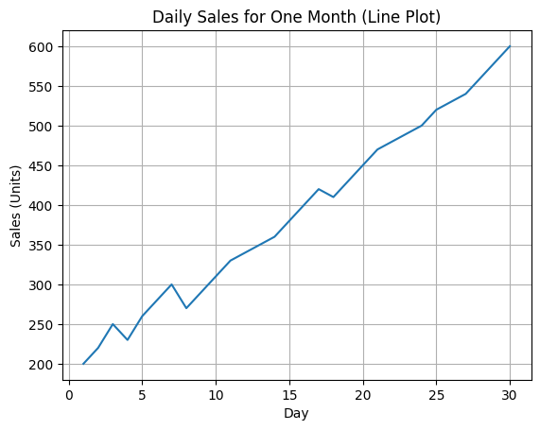
Code 2:
import matplotlib.pyplot as plt

# Example sales data for one month (same data)
days = list(range(1, 31))
sales = [200, 220, 250, 230, 260, 280, 300, 270, 290, 310,
330, 340, 350, 360, 380, 400, 420, 410, 430, 450,
470, 480, 490, 500, 520, 530, 540, 560, 580, 600]

plt.scatter(days, sales)
plt.title("Daily Sales for One Month (Scatter Plot)")
plt.xlabel("Day")
plt.ylabel("Sales (Units)")
plt.grid(True)
plt.show()
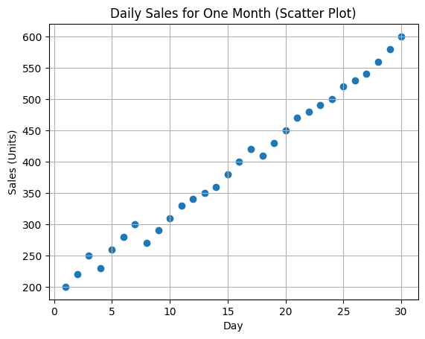
CODE3
import matplotlib.pyplot as plt

# Monthly sales for a year (example data)
months = ["Jan", "Feb", "Mar", "Apr", "May", "Jun",
"Jul", "Aug", "Sep", "Oct", "Nov", "Dec"]

sales = [12000, 15000, 17000, 16000, 18000, 20000,
22000, 21000, 23000, 25000, 27000, 30000]

plt.bar(months, sales)
plt.title("Monthly Sales Data (Bar Plot)")
plt.xlabel("Month")
plt.ylabel("Sales (in Units)")
plt.xticks(rotation=45)
plt.show()
